1.

import math

def **ps**(x):

sr = math.sqrt(x)

return ((sr - math.floor(sr)) == 0)

x = 81

if (ps(x)):

print(*"Yes"*)

else:

print(*"No"*)



2.

a= [1,2,3,4,9,22,34,11,8,7]

print(a[::-1])



3.

a= [1,2,3,4,9,22,34,11,8,7]

b=int(len(a)/2)

c=a[0:b]

d=a[b::]

print(c[::-1])

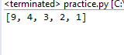

4. a= [1,2,3,4,9,22,34,11,8,7]

b=int(len(a)/2)

c=a[0:b]

d=a[b::]

print(d[::-1])



5.

a= [1,2,3,4,9,22,34,11,8,7]

a.sort()

print(a)

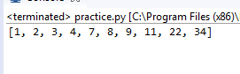

6.

a= [1,2,3,4,9,22,34,11,8,7]

a.sort()

print(a[::-1])



7.

a= [1,2,3,4,9,22,34,11,8,7]

b=int(len(a)/2)

c=a[0:b]

d=a[b::]

c.sort()

d.sort()

print(c[::]+d[::-1])

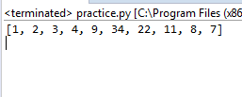

8.

a= [1,2,3,4]

b= [5,6,7,8]

print(a+b)



9.

w = *'hi this is a python class'*

print(w.find(*'i'*, 2))

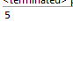

10.

s = *"python is python"*

print(s.count(*"python"*, 0, 6))

print(s.count(*"python"*, 0, 25))

